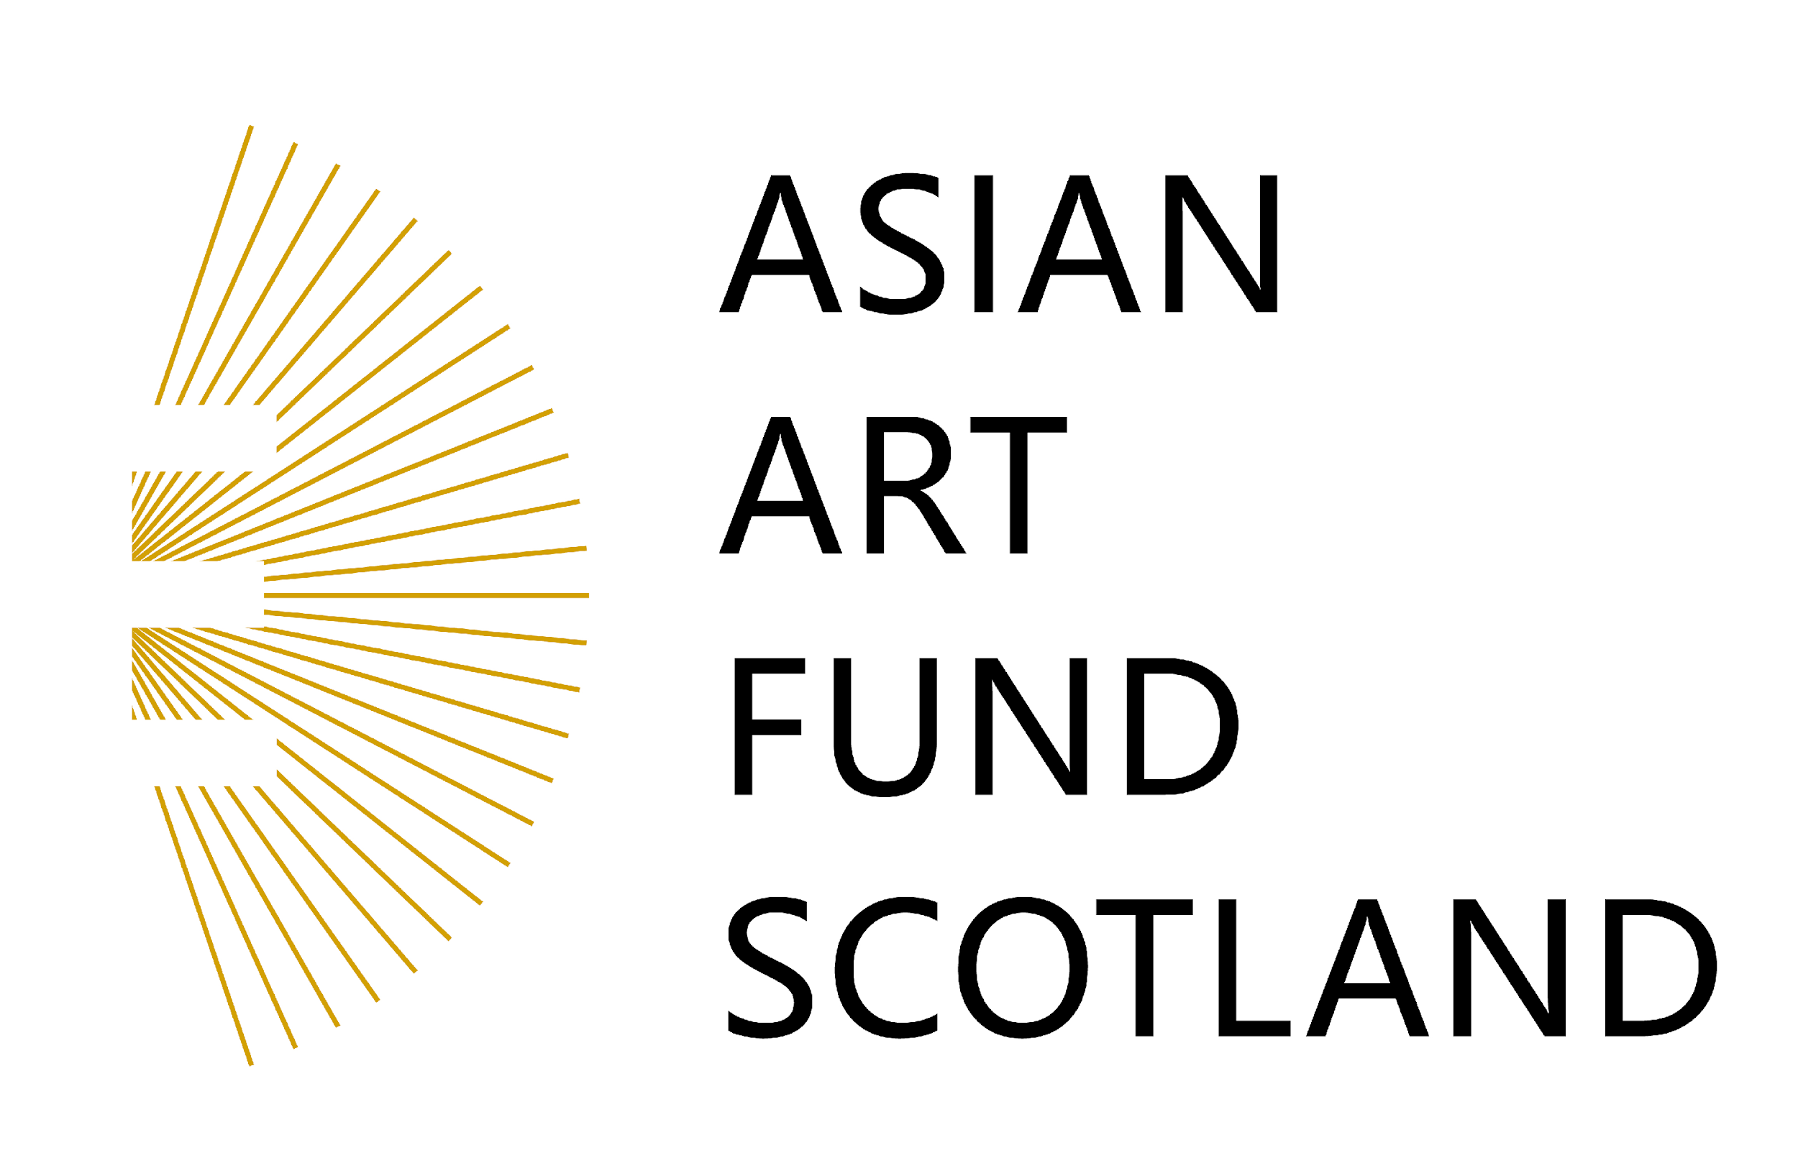

For immediate release

ASIAN ARTS AWARDS ANNOUNCES THE 2023 PRIZE WINNERS

The Asian Art Fund Scotland is proud to announce the results of the Asian Arts Awards, which was run for the 9th year at the Edinburgh Festival Fringe 2023, with the intention of encouraging and rewarding original and innovative productions made by participants who are either of Asian origin or whose work illustrates a clear link with Asian culture.

For the first time since 2019 and the ensuing pandemic, the awards were hosted by a reception at the Doubletree by Hilton Edinburgh City Centre Hotel and presented by Lyndsey Jackson, Deputy Chief Executive, Edinburgh Festival Fringe Society.

The winners are:

Best Show
Baklâ – Max Percy + Friends (Philippines)

Best Production
Fall And Flow – Theatre de la Feuille (Hong Kong/China)
Runner Up: Weathervanes – Journey To The East Productions (South East Asia/Japan)

Best Direction
Huang Ying for Journey To The West – Full Show Lane Studio (China)
Chan Chu-hei for Candide – A Voyage Of Disenchantment – Ima Collab (Hong Kong)

Best Performance
Eunji Lim & Eseul Kim for The Maids – Moosoo Theatre Group (South Korea)
Runner-up: Elizabeth Gunawan for Unforgettable Girl – Elizabeth Gunawan and Saksi Bisou with Created A Monster (East Asia)

Asian Arts Special Award
Mother Courage and Her Children, directed by Zhao Miao (China)
For his tenth anniversary of bringing shows to the Edinburgh Festival Fringe,
with a special commendation to Wang Yue for her outstanding performance in the lead role of Theatre SanTuoQi’s production of Mother Courage And Her Children.

The Asian Arts Awards was established in 2014 to encourage innovation and originality in the Asian arts and to foster global recognition for the talented artists working in this field. The Asian Arts Awards will return in 2024, so keep an eye on www.edfringe.com for information next year!

https://asianartfundscotland.org

For further information, images etc., please contact: VALERIE POTTER
tel: 07956 874590, email: valeriepottertourpr@gmail.com

